**ELE FOODS**

**EAT . LOVE . ENJOY**

**Prepared For:**

Bootcamp Training Program at Capgemini Technology Services India Ltd.,

**Prepared By:**

Swati Gupta

Konduru Pravallika

Pasupuleti Sri Harsha

**PROBLEM STATEMENT:**

To create Restaurant System Web Application for a restaurant named “ELE FOODS” which has various items at various branches.

**DESCRIPTION:**

This restaurant system is a java-based system which would help a restaurant with various branches across the country who wants to deliver food and beverages at doorstep digitally. This system is divided into two major parts i.e. admin part and user part.

**FUNCTIONAL REQUIREMENTS:**

**ATHENTICATION:**

Both admin and user need to login using their credentials to access the various functionality. A signup page is needed for creating new admin or user accounts. Forgot Password feature is also added to allow the user or admin to continue accessing their accounts in case they forget their password or want to reset it.

**ADMIN:**

For each branch, there will be a single admin.

The admin can add item, edit item, remove item, enable/disable items, accept/reject an order, and update the status of an order. All these functionalities can be performed by the admin after proper authentication.

**Customer:**

The Customer can search, filter and sort items, add to the carry box (cart), edit carry box, place an order, track and order and check my orders. All these functionalities can be performed by the customer after proper authentication.

**USE CASES :**

**Admin**

Login

View Items

Add Items

Update Items

Remove Items

Receive Orders

Accept or Reject Orders

**Customer**

Login

Sign Up

Forgot Password

Select location

View Items

Search, Sort, Filter Items

Choose the item(s)

Place order

Track Order

**USE CASES DIAGRAM:**

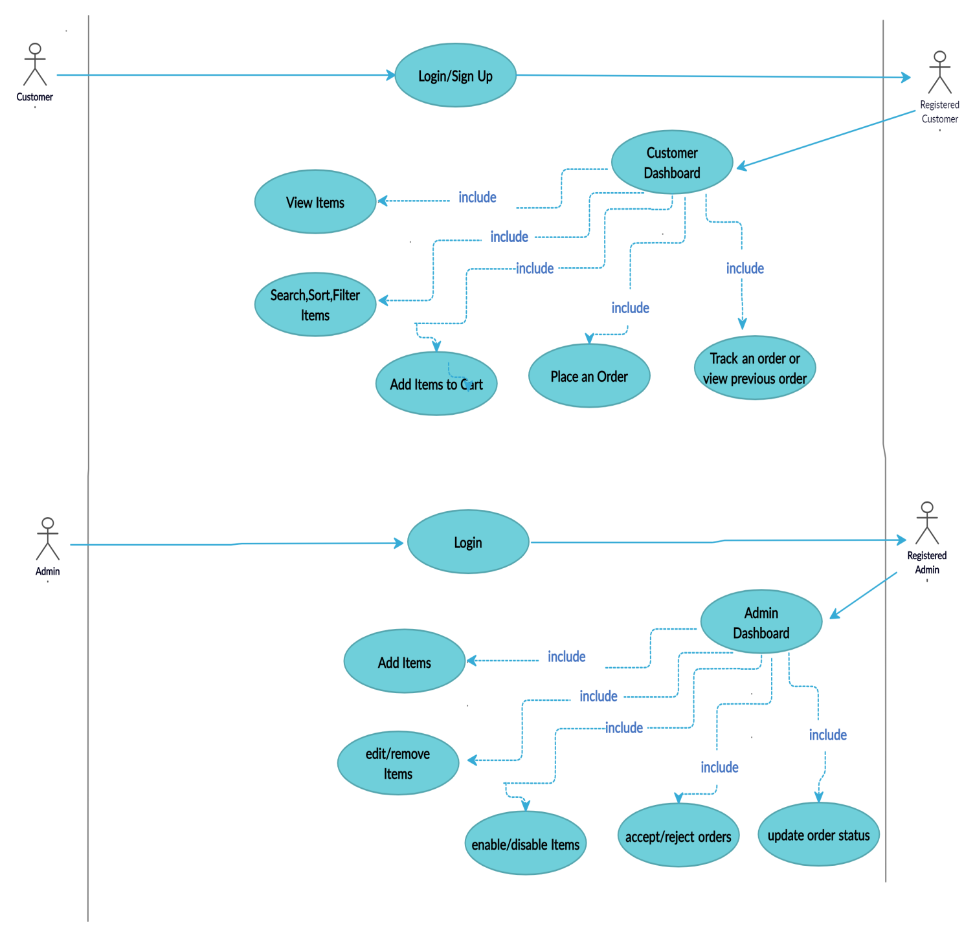

**CLASS DIAGRAM:**

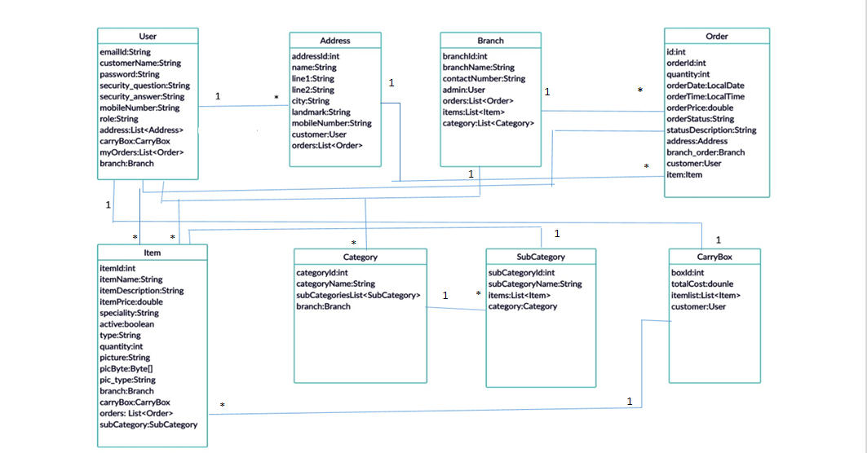

**SEQUENCE DIAGRAM (Both Admin and User):**

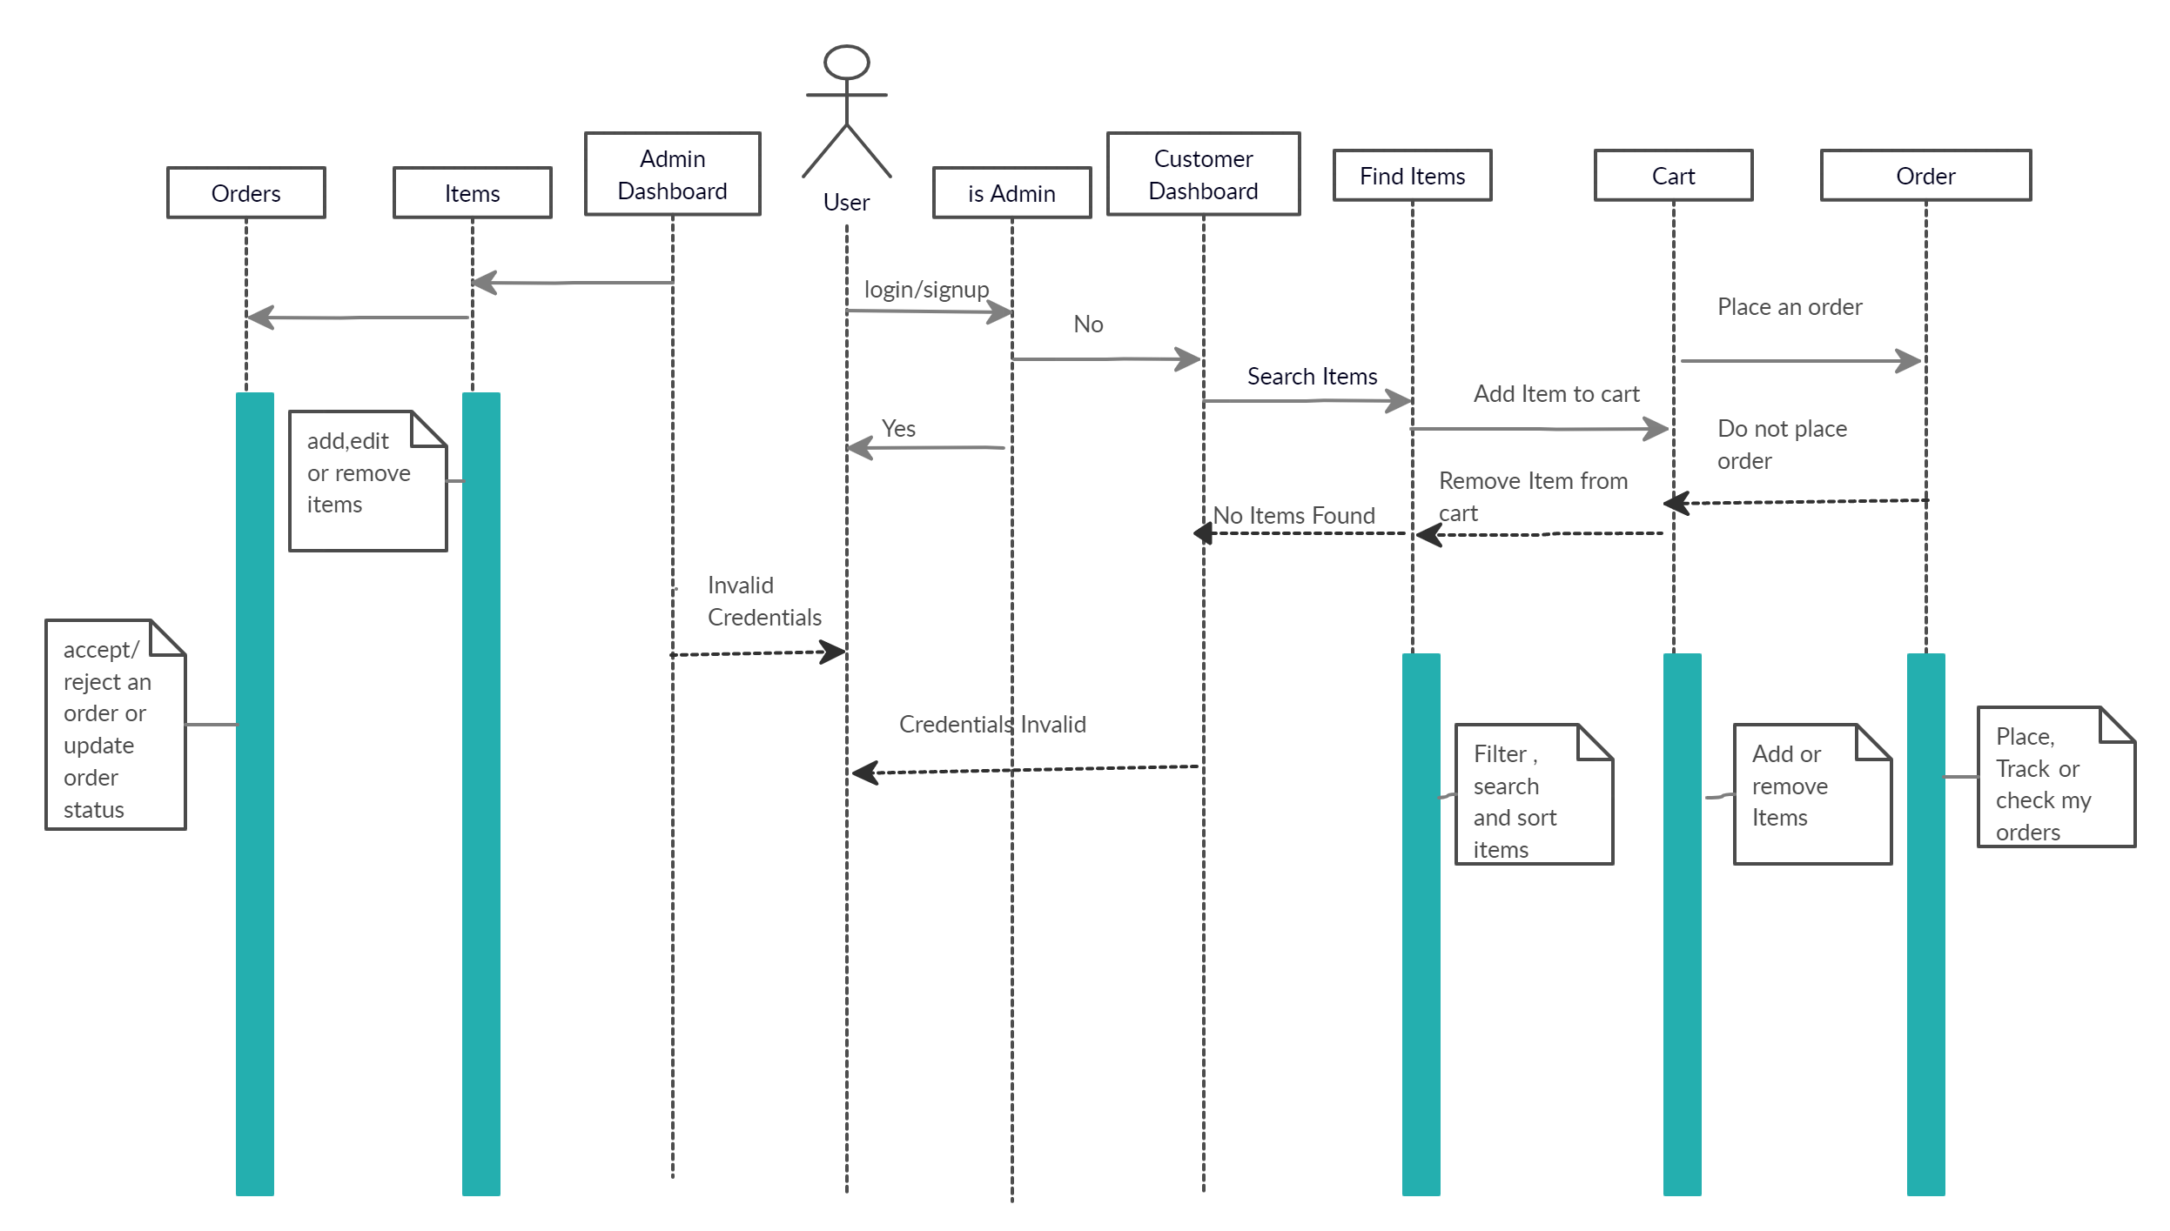

**ACTIVITY DIAGRAM (BASIC):**

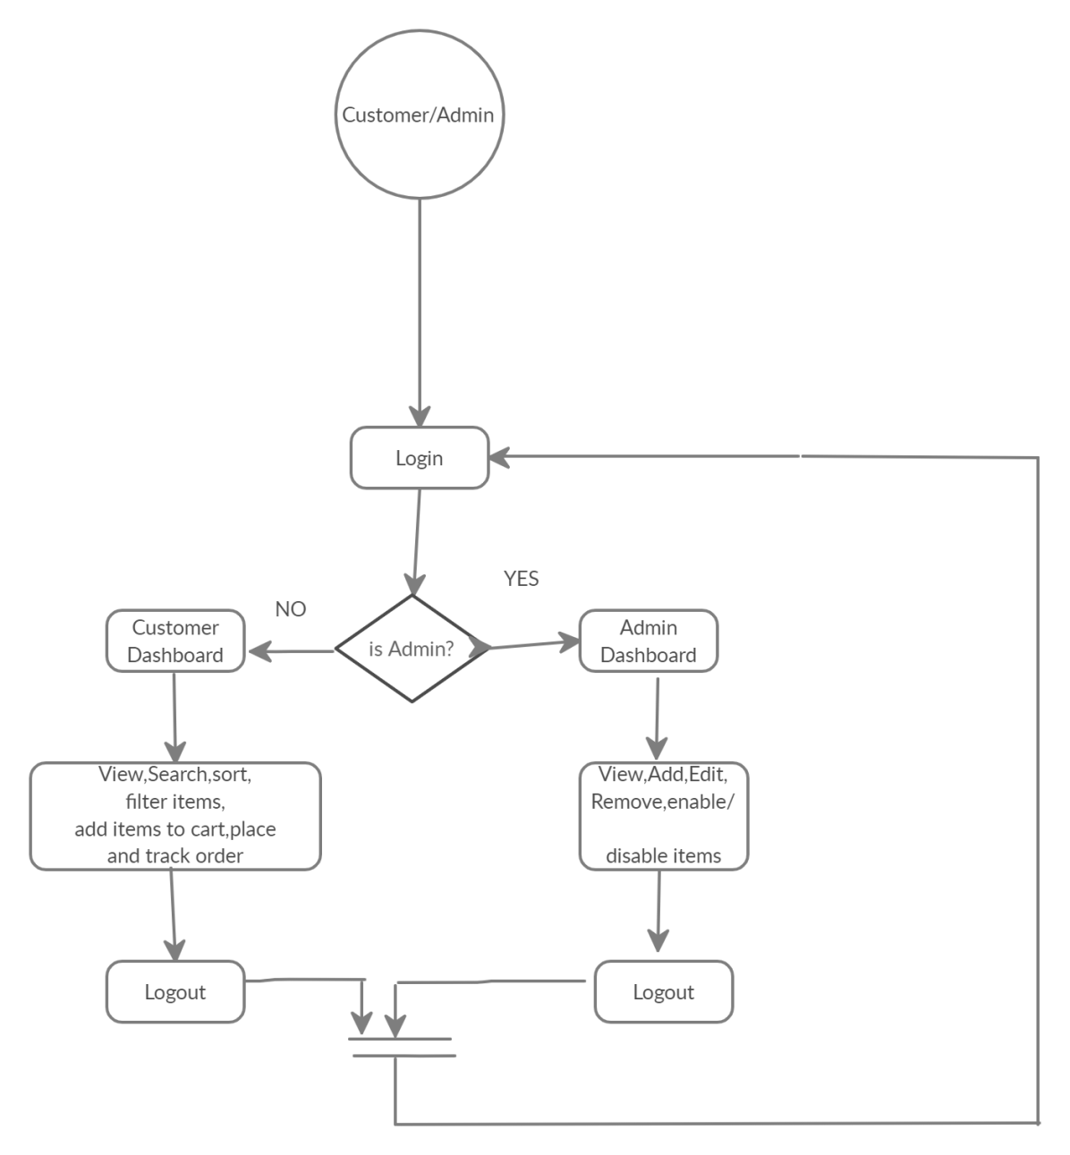

**USER ACTIVITY DIAGRAM:**

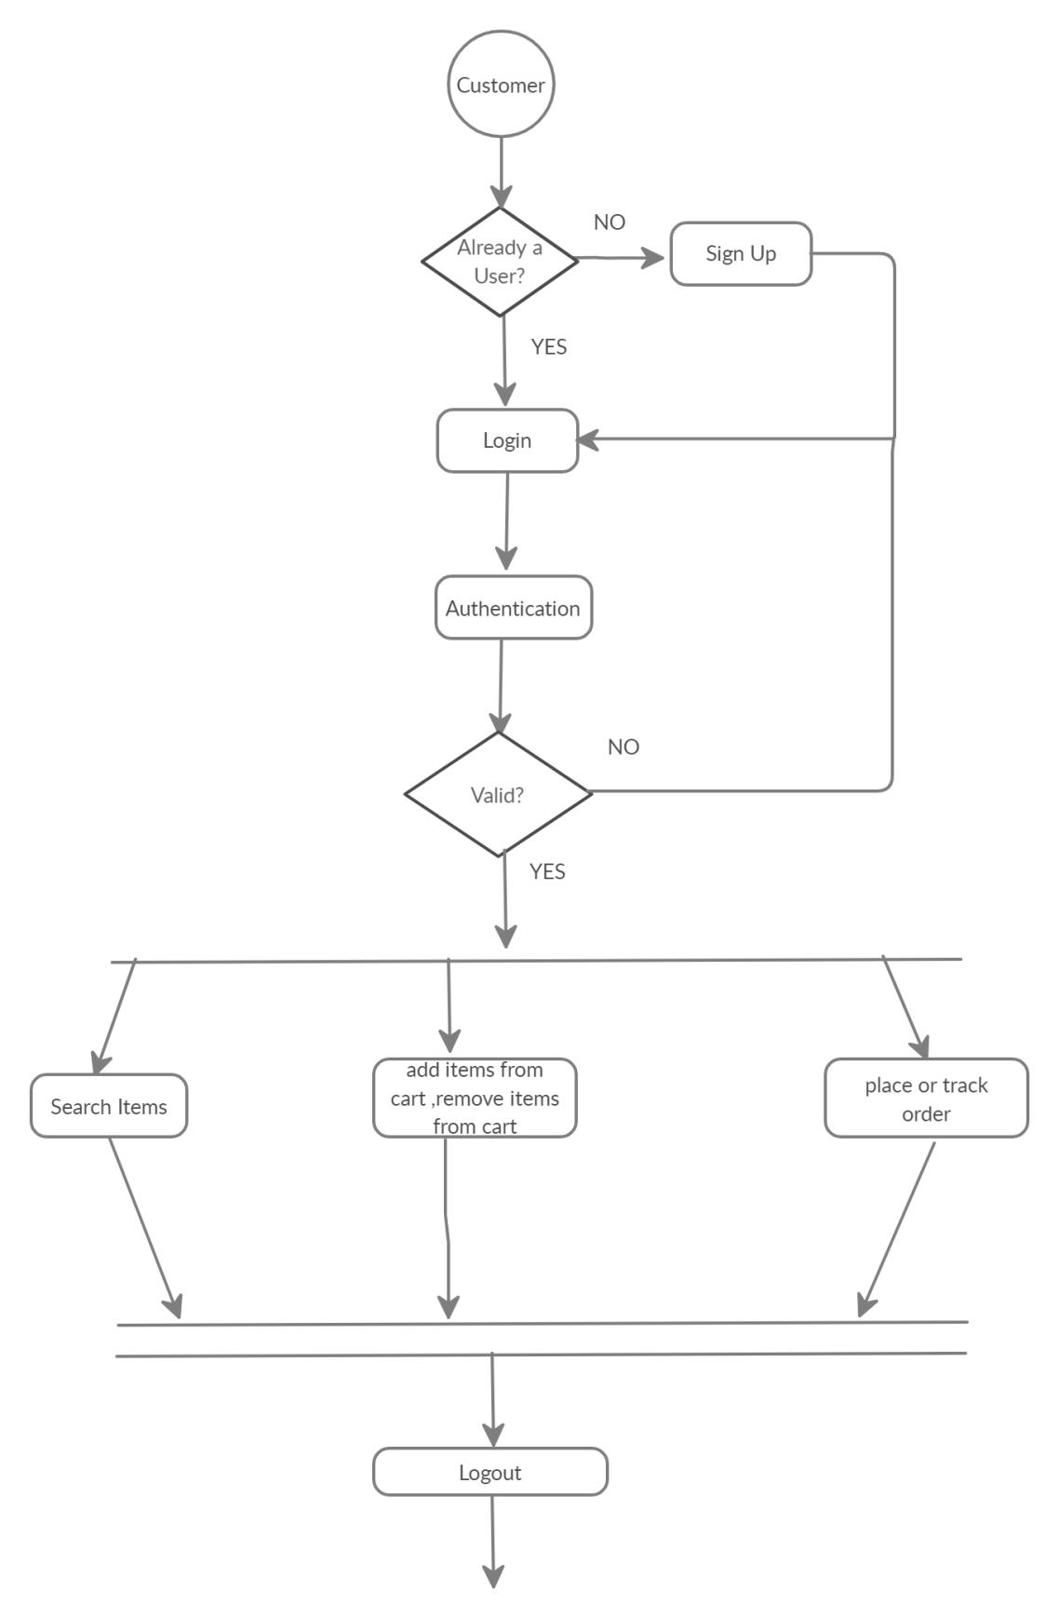

**ADMIN ACTVITY DIAGRAM:**

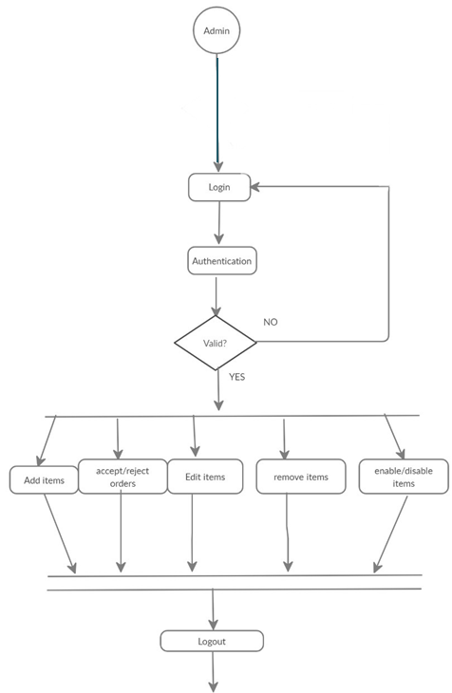

**ENTITY RELATIONSHIP DIAGRAM:**

